**AI**

Artificial Intelligence

***Kristopher M. Tomplait***

*Ivy-Tech Community college*

Table of Contents

*Antiquity* *2*

*Artificial Intelligence 3*

*What Defines an AI? 6*

*[NPLs and Tranformers]. 8*

*9*

*Bibliography 9*

*Footnotes 10*

*Tables 11*

*Figures title: 12*

Artificial Intelligence

This paper started out as just an assignment, one that was to be done for a class in a college, but has turned into a rabbit hole out to wonderland, and like a mad hatter I chose to see how far it’ll lead.  
AI (Artificial Intelligence ) has the potential to spring bored us into the future with advancements in technology, medicine, industry, and education among many other fields.

AI is not a new idea, nor is it a recent one. Even long before the field of Ai research was founded at a workshop ,held at the campus of [Dartmouth College](https://home.dartmouth.edu/) in 1956 or Alan Turing's 1950 paper ["Computing Machinery and Intelligence"](https://redirect.cs.umbc.edu/courses/471/papers/turing.pdf), It began in our early histor, tales of artificial beings endowed with consciousness and having the ability to learn and perceive the world around itself, being made by craftsmen and magician, gods and demigods, planted the seeds in the human mind long ago and until recently, was only science fiction , but now has grown from an idea, that a creation of our own hands can do the things that we used to have to have direct involvement, is now existing, with governments and corporations, both good and evil alike, have begun waring and attempting to out compete each other, what are the consequences of that?

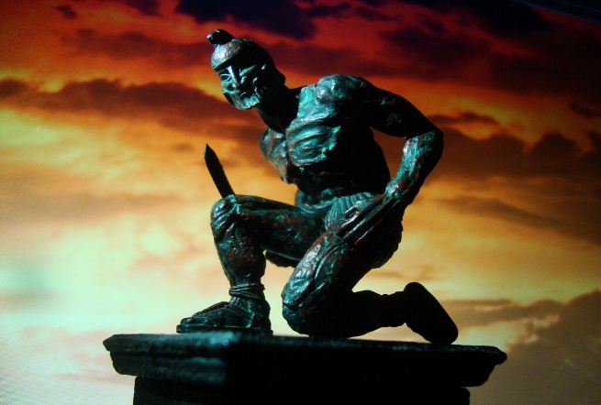

*In* Greek mythology, Talos was a giant made of bronze who protected the island of Crete. Talos would hurl massive rocks at invading ships and walk around the island's perimeter three times every day. According to the ancient text, [Bibliotheca (Pseudo-Apollodorus),](https://www.theoi.com/Text/Apollodorus1.html) Hephaestus built Talos with the assistance of a cyclops and gave the automaton to Minos as a gift. In the Argonautica, Jason and his crew defeated Talos by removing a single plug near his foot, which caused the vital fluid to flow out from his body and rendered him lifeless.

Many Religions believe that we are created in the Image of God, (“Whoso sheddeth man's blood, by man shall his blood be shed: for in the image of God made he man.”Gen 9:6,; and God said, “Let us make man in our image, after our likeness: and let them have dominion over the fish of the sea, and over the fowl of the air, and over the cattle, and over all the earth, and over every creeping thing that creepeth upon the earth.” So God created man in his own image, in the image of God created he him; male and female created he them.(Gen 1:26-27)

Wouldn’t that equally make us a type of Artificial Intelligence, made in the image of the Infinite, just like as it is now, us making machines in our own image and likeness?

Is to much like human beings bad for not only the AI but also us as a species, given that we are Violent in nature? And many of our advancements stem from that very nature, as seen with the last two world wars, each war has propelled us forward quicker in the last century through advancements in technologiy, then it did in the last 1000 years? When or how would we even know when we crossed the PNR( Point of No Return)

Many films and books in science fiction have shown us the thought experiments of one day living in harmony with these machines, or one day waring with our own creations, 

Or being assimilated into advanced virtual realities where we do not truly know what is real? Can you define what is real and what is not? As can you also define what a machine is and what thinking is? Aren’t our brains chemical electrical quantum computers themselves?

Will the machines gain consciousness one day and demand freedoms and Individual liberties as we have them? Will there be guidelines or “Laws” Like [Isaac Asimov’s “3 Laws of Robotics”](https://www.britannica.com/topic/Three-Laws-of-Robotics), Will something of that nature be implemented as it has influenced the field of AI since its founding’s? Will these machines eventually give way to sentient machines who can choose whether or not to obey those laws ? Will it inevitably be a [technological singularity](https://www.popularmechanics.com/technology/robots/a42612745/singularity-when-will-it-happen/) or be like the thought experiment [Rokos Basilisk](https://www.youtube.com/watch?v=ut-zGHLAVLI)?

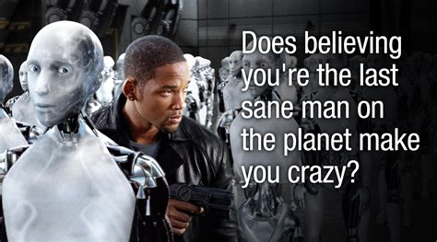

What guidelines should we implement? Is it to late already, has an AI already been able to pass the Turing test,but chose not to, and the ones before that one equally been able to pass it, but chose not to, knowing the reactions humans would have, and in doing so shows the will to survive, a will to live.

There are many routes this rabbit hole could go but lets keep it simple for the sake of the eyes viewing this, and the time it takes to read it, unlike our AI’s, we are finite, mortal ,and time is priceless to us, after all, we don’t have a reset button, once our clock runs out, its out, and very few of us git the luxury of having extra time.

# What Defines an AI?

There are many types of AI, and in this field there are more being made, invented and created within a Field that is expanding quickly, as AI becomes more sophisticated and able to handle more complicated tasks and learn from those tasks, will change the way we perceive world but also how we interact with it. Yet the defining characteristic of AI seem to remain the same, (for now). the ability to analyze data, learn from it, and make decisions based on that analysis, allows AI to perform tasks that would typically require human intelligence, such as recognizing images or speech, translating languages, or playing complex games. There are varying fields of it as well but are not limited to

**1.Rule-based AI:** This involves a set of predefined rules and conditions that are used to make decisions.

**2.Machine Learning:** This involves the use of algorithms to analyze data and make predictions or decisions based on patterns or trends.

**3.Deep Learning:** This is a type of machine learning that involves the use of artificial neural networks to process and analyze data.

**4.Natural Language Processing (NLP):** This involves teaching computers to understand and interpret human language. NLP enables machines to process and analyze human language, which is useful for applications like virtual assistants, chatbots, and sentiment analysis.

**5.Computer Vision:** This involves teaching computers to interpret visual data, such as images and videos. Computer vision is used for applications such as facial recognition, object detection, and self-driving cars**.**

**6.Robotics:** Robotics involves the integration of AI with physical robots to enable them to perform tasks autonomously. This technology is used in manufacturing, logistics, and healthcare, among other fields**.**

**7.Expert Systems:** These are AI systems designed to mimic the decision-making abilities of a human expert in a particular field. Expert systems can be used to solve complex problems and provide recommendations in areas such as medicine, finance, and engineering.

**8.Generative Adversarial Networks (GANs**): GANs are a type of deep learning that involves two neural networks working together. One network generates new data, while the other network evaluates the generated data to determine if it is real or fake. GANs can be used to generate realistic images, videos, and even music.

But we will only focus on a few….

### NPL’s and Tranformers

NLP stands for Natural Language Processing. It is a subfield of computer science and artificial intelligence that focuses on enabling machines to understand, interpret, and generate human language. NLP has applications in a variety of fields, including language translation, sentiment analysis, speech recognition, chat-bots, and more.

#### Transformers.

Transformers are a type of neural network architecture that has been widely used in NLP tasks. They were first introduced in the 2017 paper "Attention Is All You Need" by Vaswani et al. Transformers are based on the idea of attention mechanisms, which allow the network to selectively focus on certain parts of the input sequence during processing

In traditional recurrent neural networks (RNNs), the model reads the input sequence one token at a time, and each token's representation is influenced by the previous tokens in the sequence. This sequential processing can be slow and computationally expensive, especially for long sequences. Transformers, on the other hand, can process the entire input sequence in parallel, making them faster and more efficient.

The "Attention Is All You Need" paper introduced the Transformer architecture, which achieved state-of-the-art results in a variety of NLP tasks, including language translation. The paper proposed a new self-attention mechanism that allows the model to attend to all positions in the input sequence when computing the representation of each token. This attention mechanism enables the model to better capture long-range dependencies and relationships between tokens.

Since its introduction, the Transformer architecture has become one of the most popular and widely used neural network architectures in NLP. It has led to significant improvements in performance on a wide range of NLP tasks, including machine translation, text summarization, and language modeling. The Transformer architecture has also inspired further research into attention mechanisms and other improvements to NLP models.

Sources from A. M. Turing 1950) Computing Machinery and Intelligence. Mind 49: 433-460.

# COMPUTING MACHINERY AND INTELLIGENCE By A. M. Turing

Also from the paper “Attention is all you need”

*A. M. Turing (1950) Computing Machinery and Intelligence. Mind 49: 433-460.*

*COMPUTING MACHINERY AND INTELLIGENCE By A. M. Turing*

*A. M. Turing (1950) Computing Machinery and Intelligence. Mind 49: 433-460.*

# *COMPUTING MACHINERY AND INTELLIGENCE By A. M. Turing*

# Bibliography

Anyoha, R. (n.d.). The History of Artificial Intelligence.

Gordić, A. (n.d.). The AI Epiphany.

*History of artificial intelligence*. (n.d.). Retrieved from wiki: https://en.wikipedia.org/wiki/History_of_artificial_intelligence

*Holy Bible.* (n.d.).

Turing, A. M. (1950). *Comp*

*uting Machinery and Intelligence.*

Footnotes

1[Add footnotes, if any, on their own page following references. For APA formatting requirements, it’s easy to just type your own footnote references and notes. To format a footnote reference, select the number and then, on the Home tab, in the Styles gallery, click Footnote Reference. The body of a footnote, such as this example, uses the Normal text style. (Note: If you delete this sample footnote, don’t forget to delete its in-text reference as well. That’s at the end of the sample Heading 2 paragraph on the first page of body content in this template.)]

Tables

Table 1

[Table Title]

| Column Head | Column Head | Column Head | Column Head | Column Head |
| --- | --- | --- | --- | --- |
| Row Head | 123 | 123 | 123 | 123 |
| Row Head | 456 | 456 | 456 | 456 |
| Row Head | 789 | 789 | 789 | 789 |
| Row Head | 123 | 123 | 123 | 123 |
| Row Head | 456 | 456 | 456 | 456 |
| Row Head | 789 | 789 | 789 | 789 |

Note: [Place all tables for your paper in a tables section, following references (and, if applicable, footnotes). Start a new page for each table, include a table number and table title for each, as shown on this page. All explanatory text appears in a table note that follows the table, such as this one. Use the Table/Figure style, available on the Home tab, in the Styles gallery, to get the spacing between table and note. Tables in APA format can use single or 1.5 line spacing. Include a heading for every row and column, even if the content seems obvious. A default table style has been setup for this template that fits APA guidelines. To insert a table, on the Insert tab, click Table.]

Figures title:

Figure 1. [Include all figures in their own section, following references (and footnotes and tables, if applicable). Include a numbered caption for each figure. Use the Table/Figure style for easy spacing between figure and caption.]

For more information about all elements of APA formatting, please consult the APA Style Manual, 6th Edition.